 

INSTITUTE FOR ADVANCED

COMPUTING AND

SOFTWARE DEVELOPMENT

AKURDI, PUNE

Documentation On

**“Online Doctor Appointment System”**

PG-DAC FEB 2020

*Submitted By:*

**Group No: 44**

**Names & roll numbers**

**Gayatri sharma-1133**

**Komal dhamankar-1130**

**Prashant Karhale Mr.**

**Centre Coordinator Project Guide**

# Table of Contents

1. **Introduction ..................................................................................................................... 1**

Document Purpose ....................................................................................................... 2

Problem Statement ....................................................................................................... 2

Product Scope .............................................................................................................. 2

Aim & Objectives ........................................................................................................ 2

1. **Overall Description ......................................................................................................... 3**

Product Perspective...................................................................................................... 3

Benefits of Society Management System ..................................................................... 3

User and Characteristics ............................................................................................... 3

Operating Environment ................................................................................................ 3

Design and Implementation Constraints ....................................................................... 3

1. **Requirements Specification ............................................................................................ 4**

External Interface Requirements .................................................................................. 4

3.3 Non-Functional Requirements ................................................................................... 12

1. **System Diagram ............................................................................................................ 11**

Activity Diagram ....................................................................................................... 11

Data Flow Diagram .................................................................................................... 13

Class Diagram ........................................................................................................... 15

Use Case Diagram ..................................................................................................... 16

ER Diagram ............................................................................................................... 16

1. **Table Structure ............................................................................................................. 17**

Flat owners ................................................................................................................ 17

Notices ...................................................................................................................... 17

Complaints ................................................................................................................ 17

Visitors ...................................................................................................................... 18

Bill ............................................................................................................................ 18

Workers ..................................................................................................................... 18

1. **Conclusion ..................................................................................................................... 19**

Future Scope .............................................................................................................. 19

1. **References ...................................................................................................................... 20**

# List of Figures

Figure 1 Admin Activity Diagram ................................................................................... 11

Figure 2 Doctor Activity Diagram ............................................................................. 12

Figure 3 Patient Activity Diagram.............................................................................. 12

Figure 4 Level 0 Data Flow Diagram ............................................................................... 13

Figure 5 Level 1 Data Flow Diagram ............................................................................... 13

Figure 6 Level 2 Data Flow Diagram for Admin .............................................................. 14

Figure 7 Level 2 Data Flow Diagram for Doctor ....................................................... 14

Figure 8 Level 2 Data Flow Diagram for Patient ........................................................ 15

Figure 9 Class Diagram ................................................................................................... 15

Figure 10 Use Case Diagram ........................................................................................... 16

Figure 11 ER Diagram ..................................................................................................... 16

# Introduction

In our daily life we face a lot of problems. Disease is one of most common issues for a person’s life.If anybody is ill and wants to visit a doctor for checkup, he or she needs to visit the hospital and waits until the doctor is available. The patient also waits in a queue while getting appointment. If the doctor cancels the appointment for some emergency reasons then the patient is not able to know about the cancelation of the appointment unless or until he or she visits the hospital. So, it's necessary to get a consultation with Doctors whenever we got affected with various diseases. As the internet is now available for everyone therefore anyone can use the online appointment system to overcome such problems and inconvenience for the patients.

.

**Document Purpose**

**Admin:**

Admin needs to login with username and password and in the admin home screen, he can see the basic functionalities of admin. Admin can view the registered doctors and patients. He can also view the patient’s request and doctors requests and he will confirm the patients and doctors requests.

**Doctor:**

Doctor need to be registered by giving the necessary details like timing, fees etc. After registering he need to log in and in the home screen he can view the basic functionalities. He can view the patient request forwarded from admin and he can accept and he can also view the feedback given by patients.

**Patient:**

The patient needs to be registered and log in after logging on he can search for the doctor by giving availability, the reason or problem. Basing on the doctor availability the admin will confirm the booking request and will send to mail that the booking is confirmed he can also view in the status and he can also give feedback basing the performance of the doctor.

## 

## Problem Statement

## Under manual system, you have to first wait in line to take appointment for the doctors and wait for your time to have meet with them and discuss on your health problems.As you have to provide your information and other reports many times at different places such as the medicine store which is again a burden of carrying documents. You have to be present physically at the doctor’s cabin. Patients have to visit on another day of after some hours to take their health reports which involves extra care person with patients anytime. Under manual system, the only accepted payment method

**Product Scope**

There is several online appointment scheduling tools in the marketplace, some of which are feature-loaded, easy to setup and cheap. For doctors, online appointment scheduling brings a lot of value add services and benefits, like engaging the patient, making the patient feel appreciated, and being able to store patients’ data securely for future reference. But the most wonderful and useful advantage is that online appointment scheduling is amazingly low cost.

## Aims & Objectives

**Specific goals are:** -

* The main objective of the Project on Doctor Appointment System is to manage the details of Doctor Appointment Patient,Booking,
* Doctor Schedule.It manages all the information about Doctor ,Doctor Fees,Doctor Schedule ,Doctor.The project is totally built at administrative end thus only the adminstrator is guaranteed the access.
* The purpose of the project is to build an application program to reduce the manual work for managing the Doctor,Appointment,Doctor Fees,Patient.It tracks all the details about the Patient,Booking,Doctor Schedule

**Product Perspective:**

**Existing system function:**

There is several online appointment scheduling tools in the marketplace, some of which are feature-loaded, easy to setup and cheap. For doctors, online appointment scheduling brings a lot of value add services and benefits, like engaging the patient, making the patient feel appreciated, and being able to store patients’ data securely for future reference. But the most wonderful and useful advantage is that online appointment scheduling is amazingly low cost.

**PROPOSED SYSTEM :**

In the proposed system the doctors patients are brought to one platform will allow patients to be more flexible they can register and search for the doctors basing on the ailability list of doctors will be shown and patient can book by selecting  the time slots and the admin will confirm the booking so everything is computerized an done very fast which will save time.

## Benefits of Online Doctor Appointment System

* This system helps to reduce the waiting time of the patient.
* User can select the appointment time according to his preference.
* Available and booked slots are shown in effective graphical user interface.

**Users and Characteristics:**

**For patients:**

* Register as an patient account
* Booking an appointment
* Cancelling an appointment
* View their booking status
* Check doctor availability
* Search doctor
* Feedback

**For Admin:**

* Register as an admin account
* Add doctor in database
* View all appointments
* View all doctors
* View all patients

**For Doctor:**

* View My Details
* View appointment list
* View Patients
* Feedback

**Operating Environment:**

**Server Side:**

**Processor:** Intel® Xeon® processor 3500 series

**HDD:** Minimum 500GB Disk Space

**RAM:** Minimum 2GB

**OS:** Windows 8.1, Linux 6

**Database:** Oracle 11g

**Client Side (minimum requirement):**

**Processor:** Intel Dual Core

**HDD:** Minimum 80GB Disk Space

**RAM:** Minimum 1GB

**OS:** Windows 7, Linux

**Design and Implementation Constraints:**

* The application will use Ajax, JavaScript, jQuery and css as main web technologies.
* HTTP and FTP protocols are used as communication protocols. FTP is used to upload the web application in live domain and the client can access it via HTTP protocol.
* Several types of validations make this web application a secured one and SQL Injections can also be prevented.
* Since Online Doctor Appointment System is a web-based application, internet connection must be established.
* The Online Doctor Appointment System will be used on PCs and will function via internet or intranet in any web browser.

# 3.Specific Requirement

**External Interface Requirements:**

**User Interfaces:**

* All the users will see the same page when they enter in this website. This page asks the users a username and a password.
* After being authenticated by correct username and password, user will be redirect to their corresponding profile where they can do various activities.
* The user interface will be simple and consistence, using terminology commonly understood by intended users of the system. The system will have simple interface, consistence with standard interface, to eliminate need for user training of infrequent users.

**Hardware Interfaces:**

* No extra hardware interfaces are needed.
* The system will use the standard hardware and data communication resources.
* This includes, but not limited to, general network connection at the server/hosting site, network server and network management tools.

**Application Interfaces:**

**OS:** Windows 7, Linux

**Web Browser:**

The system is a web-based application; clients need a modern web browser such as Mozilla Firebox, Internet Explorer, Opera, and Chrome. The computer must have an Internet connection in order to be able to access the system.

**Communications Interfaces:**

* This system uses communication resources which includes but not limited to, HTTP protocol for communication with the web browser and web server and TCP/IP network protocol with HTTP protocol.
* This application will communicate with the database that holds all the booking information. Users can contact with server side through HTTP protocol by means of a function that is called HTTP Service. This function allows the application to use the data retrieved by server to fulfil the request fired by the user.

# 4.System Design

## Activity Diagram

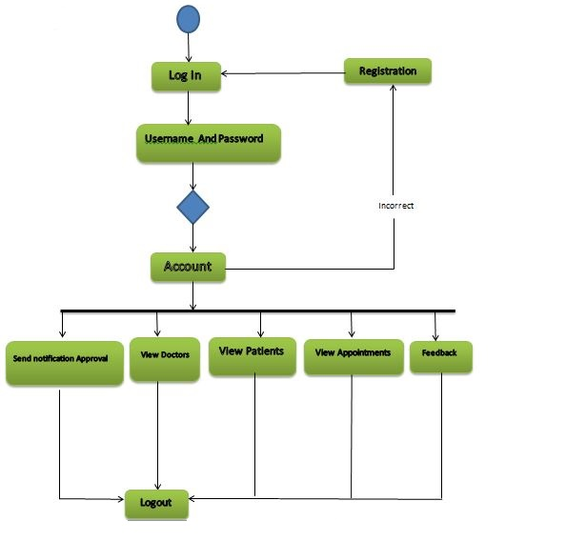

**Figure 1: Admin Activity Diagram**

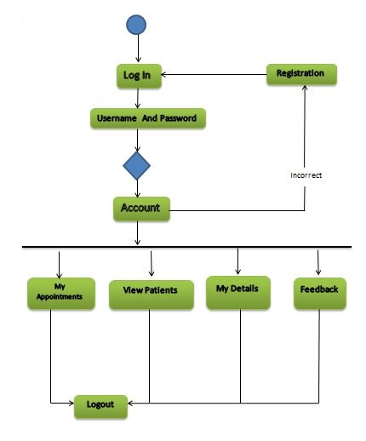

**Figure 2: Doctor Activity Diagram**

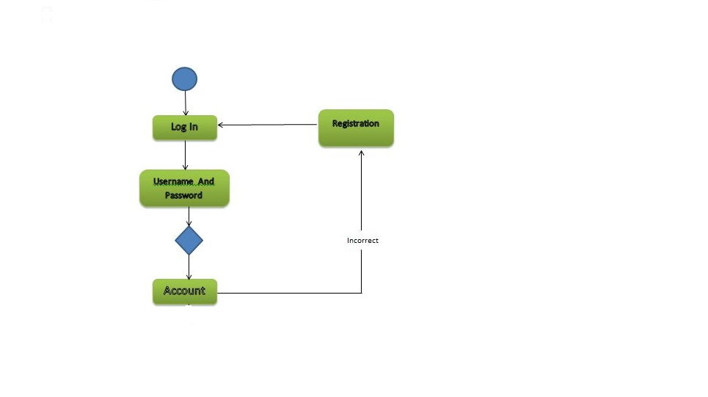

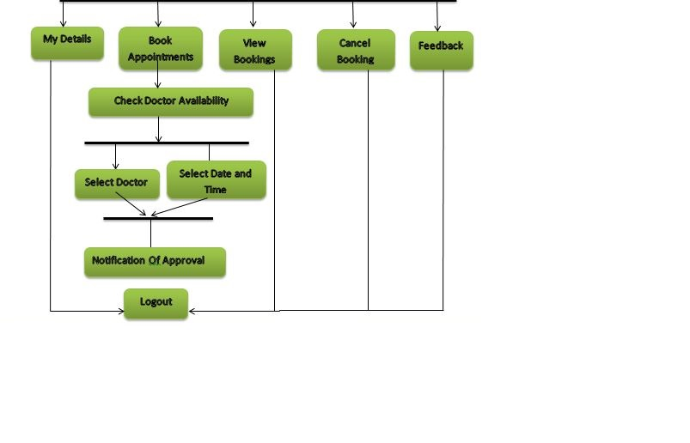 **Figure 3: Patient Activity Diagram**

## 

## Data Flow Diagram

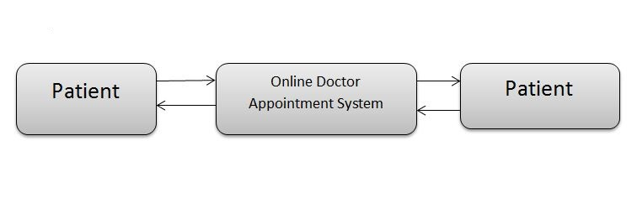

**Figure 4: Level 0 Data Flow Diagram**

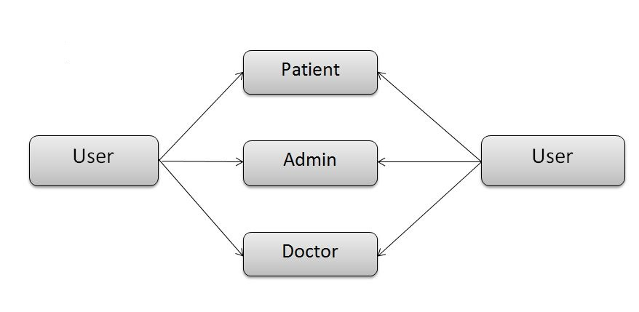

**Figure 5: Level 1 Data Flow Diagram**

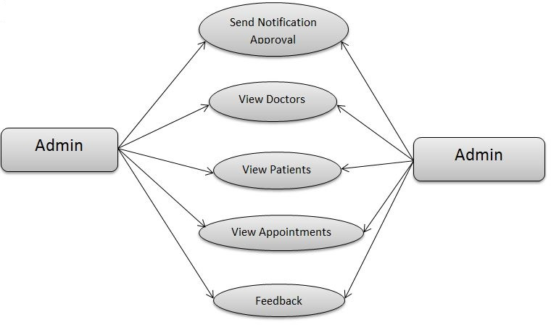

**Figure 6: Level 2 Data Flow Diagram for Admin**

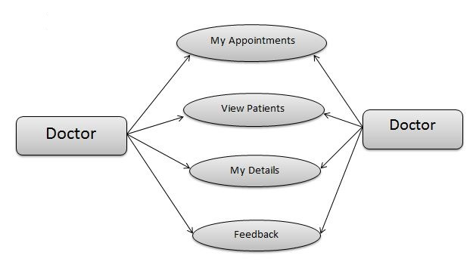

**Figure 7: Level 2 Data Flow Diagram for Doctor**

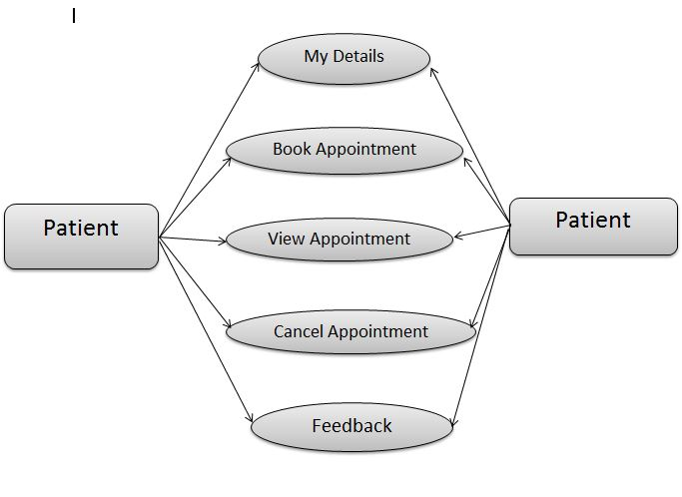

**Figure 8: Level 2 Data Flow Diagram for Patient**

## Class Diagram

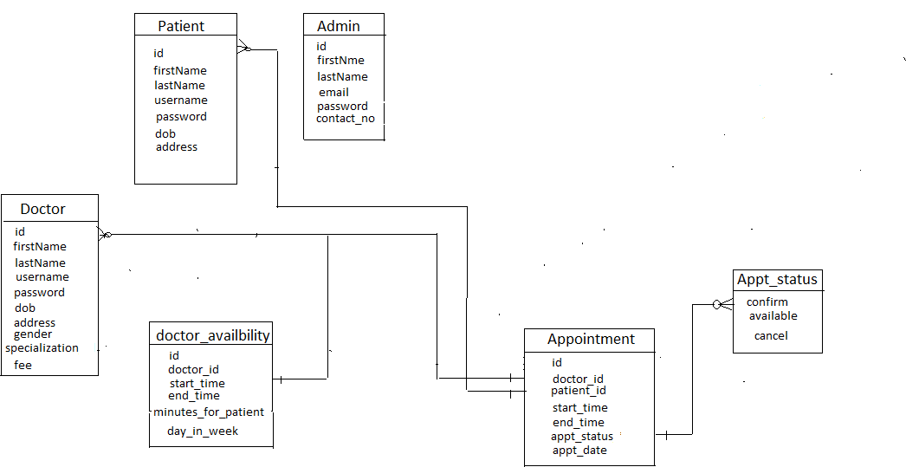

**Figure 9: Class Diagram**

## 

## USE Diagram

## 

**Figure 10: Use Case Diagram**

## 

**ER Diagram**

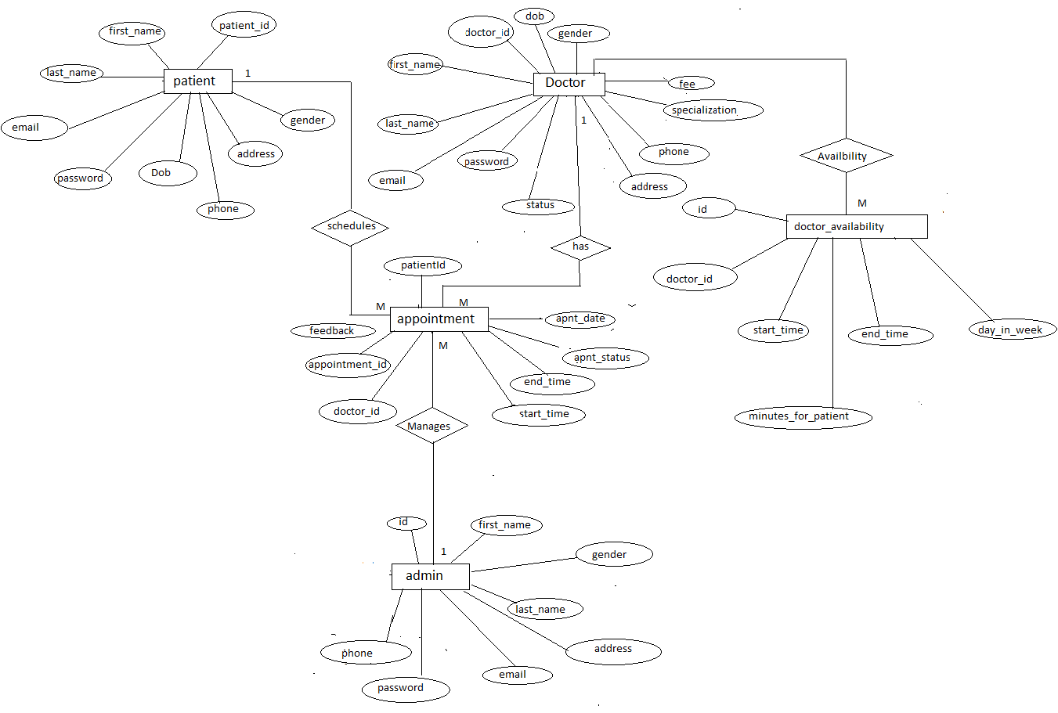

**Figure 11: ER Diagram**

# 

# 5.Table Structure

**Admin:**

|  |  |  |  |  |  |
| --- | --- | --- | --- | --- | --- |
| **Field** | **Type** | **Null** | **Key** | **Default** | **Extra** |
| adminId | int | No | PRI | NULL | Auto_increment |
| address | Varchar2(255) | YES |  | NULL |  |
| email | Varchar2(30) | YES | UNI | NULL |  |
| firstName | Varchar2(30) | YES |  | NULL |  |
| gender | Varchar2(10) | YES |  | NULL |  |
| lastName | Varchar2(30) | YES |  | NULL |  |
| password | Varchar2(255) | YES |  | NULL |  |
| phone | Varchar2(12) | YES |  | NULL |  |

**Patients:**

|  |  |  |  |  |  |
| --- | --- | --- | --- | --- | --- |
| **Field** | **Type** | **Null** | **Key** | **Default** | **Extra** |
| patientId | int | No | PRI | NULL | Auto_increment |
| address | Varchar2(30) | YES |  | NULL |  |
| dob | date | YES |  | NULL |  |
| email | Varchar2(30) | YES |  | NULL |  |
| firstName | Varchar2(30) | YES |  | NULL |  |
| gender | Varchar2(10) | YES |  | NULL |  |
| lastName | Varchar2(30) | YES |  | NULL |  |
| password | Varchar2(30) | YES |  | NULL |  |
| phone | Varchar2(12) | YES | UNI | NULL |  |

**Complaints:**

**Visitors:**

**Doctors**

|  |  |  |  |  |  |
| --- | --- | --- | --- | --- | --- |
| **Field** | **Type** | **Null** | **Key** | **Default** | **Extra** |
| doctor_id | int | No | PRI | NULL | Auto_increment |
| address | Varchar2(30) | YES |  | NULL |  |
| dob | date | YES |  | NULL |  |
| doctor_specialization | Varchar2(20) | YES |  | NULL |  |
| email | Varchar2(30) | YES |  | NULL |  |
| fees | double | NO |  | NULL |  |
| first_name | Varchar2(30) | YES |  | NULL |  |
| gender | Varchar2(10) | YES |  | NULL |  |
| lastName | Varchar2(30) | YES |  | NULL |  |
| password | Varchar2(30) | YES |  | NULL |  |
| phone | Varchar2(12) | YES | UNI | NULL |  |
| status | Varchar2(255) | YES |  | NULL |  |
| flag | tinyint | NO |  | 0 |  |

**Appointments**

|  |  |  |  |  |  |
| --- | --- | --- | --- | --- | --- |
| **Field** | **Type** | **Null** | **Key** | **Default** | **Extra** |
| appointment_id | int | No | PRI | NULL | Auto_increment |
| appointment_date | date | YES |  | NULL |  |
| appointmen_status | Varchar2(20) | YES |  | NULL |  |
| end_time | time | YES |  | NULL |  |
| feedback | Varchar2(255) | YES |  | NULL |  |
| start_time | time | YES |  | NULL |  |
| doctor_id | int | NO | MUL | NULL |  |
| patient_id | int | NO | MUL | NULL |  |

|  |  |  |  |  |  |
| --- | --- | --- | --- | --- | --- |
| Field | Type | Null | Key | Default | Extra |
| doctor_availability_id | int | No | PRI | NULL | Auto_increment |
| day_in_week | Varchar2(20) | YES |  | NULL |  |
| end_time | time | YES |  | NULL |  |
| minutes_per_patient | int | NO |  | NULL |  |
| start_time | time | YES |  | NULL |  |
| doctor_id | int | YES | MUL | NULL |  |

# Doctor_availability:

# 6.Conclusion

# Online appointment booking system that provides patients or any user an easy way of booking a doctor’s appointment online. This is a web based application that overcomes the issue of managing and booking appointments according to user’s choice or demands.

.

# Future Scope

1.we can add printer in future.

2.we can give more advance software for doctor appointment system including more facilities.

3. we will host platform on online servers to make it accessible worldwide.

4.Integrate multiple load balancers to distribute the load of system.

5. Implement the backup mechanism for .taking backup of codebase and database on the regular basis on different servers.

## 7 . References

**ONLINE REFERENCE**

1. <https://www.freeprojectz.com/project-report/2363>
2. <https://www.researchgate.net/publication/312946008_Mr_Doc_A_Doctor_Appointment_Application_System>
3. www javatpoint.com
4. <https://github.com/girish03/Online-Appointment-Booking-System>
5. https://arxiv.org/ftp/arxiv/papers/1701/1701.08786.pdf